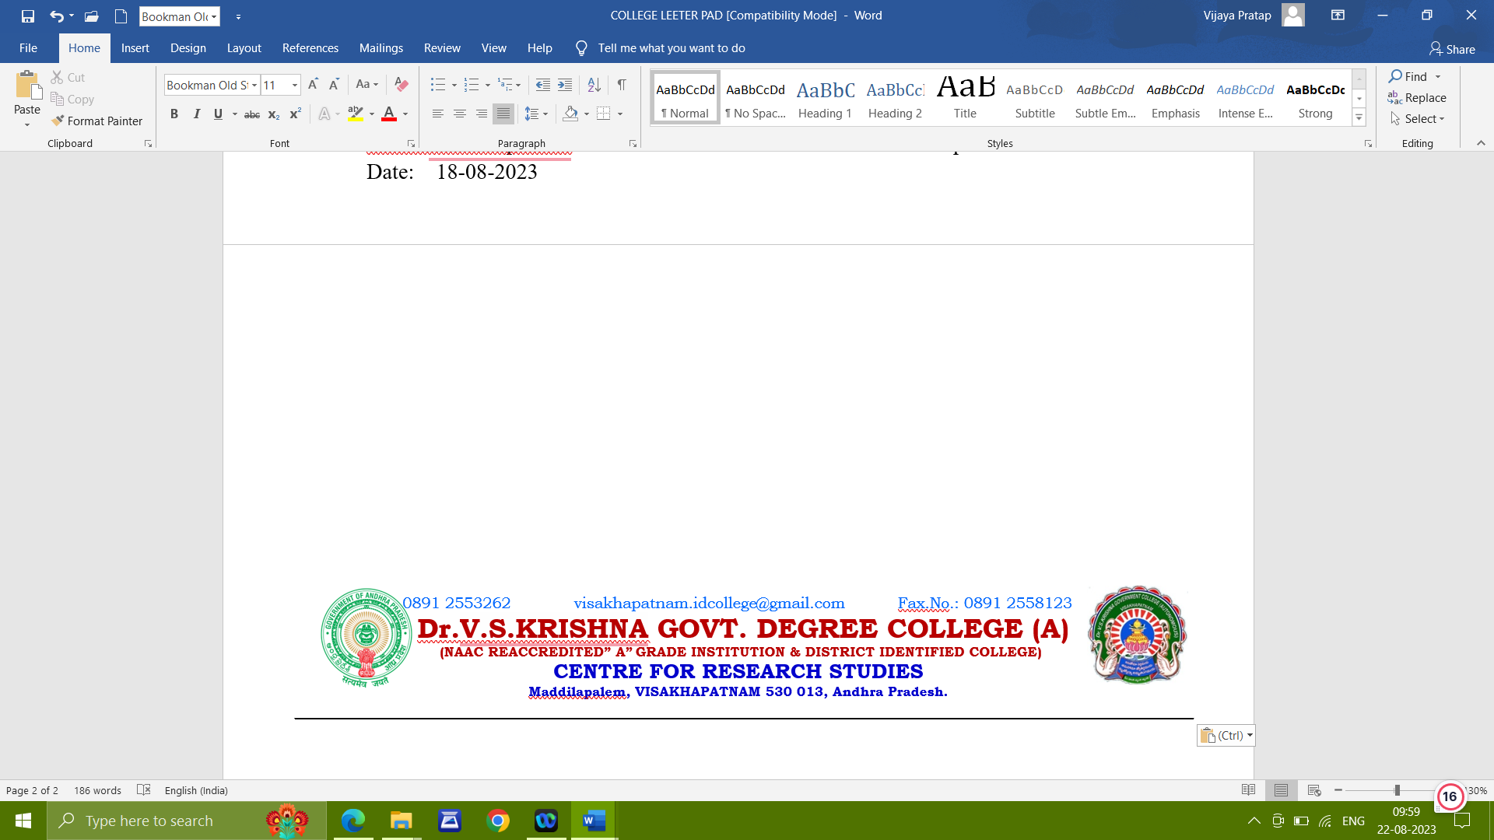

PROFILE OF
Dr.G.VIJAYA PRATAP
Lecturer in Zoology

Name : | Dr. G.VIJAYA PRATAP | 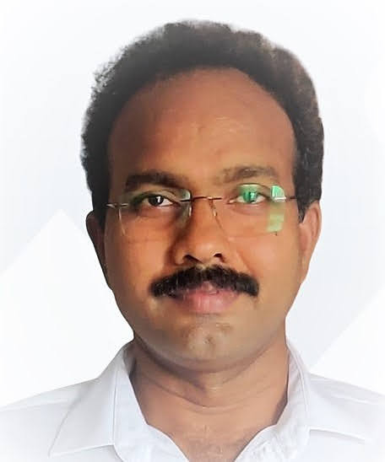
Designation: | Lecturer in Zoology
Employee ID: | 0226108
Email: | pratapgv404@gmail.com
Mobile No.: | 9949611243
Date of Birth: | 04-11-1967
Address: | Flat No. 304, Sri JK sai Towers,
Address: | Muslim thati  chetla Palem,
Address: | VISAKHAPATNAM -530016

Educational Qualifications: |  |  |  |  | M.Sc. M.Ed., |  |  |  |  |  | M.Phil.
 |  |  |  |  | Ph.D |  |  |  |  |  | NET (CSIR)
 |  |  |  |  |  |  |  |  |  |  | P.G.Diploma in Environmental Sciences
Date of First Appointment: |  |  |  |  | 15-06-1995
Date of Promotion: |  |  |  |  | 28-11-2010
Date of joining in the present station: |  |  |  |  | 21-07-2023
Date of Retirement: |  |  |  |  | 30-11-2029
Orientation Course Attended: |  |  |  |  | 01
Sl. No. |  | Name of the Course |  | From – To |  |  |  |  | University/Institution
1 |  | Orientation Course |  | 24-07-2013 to  20-08-2013 |  |  |  |  | Academic Staff College, Andhra University,Visakhapatnam.
Refresher Course Attended: 02

Sl. No. |  | Name of the Course |  | From – To |  |  |  |  | University/Institution
1 |  | Refresher Course-  Environmental sciences |  | 05-09-2012 to  25-09-2012 |  |  |  |  | Academic Staff College, Andhra University, Visakhapatnam
2 |  | Refresher Course on  Environmental sciences |  | 23-12-2019  To  05-01-2020 |  |  |  |  | Academic Staff College, Andhra University, Visakhapatnam
Seminars/ Workshops / Webinars Attended: 48

Sl. No. |  | Title of Seminar/Workshop/  Symposium/  Coference/Webinar |  | Date |  |  |  |  |  | Conducted By |  |  | Inter National/National/ State |  |  | Participated/Paper Presented
1 |  | Symposium |  | 23/12/2011 to 24/12/2011 |  |  |  |  |  | Andhra university |  |  | Inter National |  |  | Participated
2 |  | Conference |  | 16-12-2016  To  17-12-2016 |  |  |  |  |  | Andhra  University |  |  | Inter  national |  |  | Paper presented
3 |  | Conference |  | 30-06-2014 to  01-07-2014 |  |  |  |  |  | Andhra university |  |  | Inter National |  |  | Paper presented
4 |  | Conference |  | 25-10-2013 to  26-10-2013 |  |  |  |  |  | Dr.VS.Krishna  P.G College |  |  | National |  |  | participated
5 |  | Conference |  | 18-12-2014 to  19-12-2014 |  |  |  |  |  | Dr.VS.Krishna  P.G College |  |  | national |  |  | participated
6 |  | Seminar |  | 03-11-2011 |  |  |  |  |  | Dr.LB PG College |  |  | National |  |  | participated
7 |  | Seminar |  | 03-02-2014 |  |  |  |  |  | Andhra university |  |  | National |  |  | participated
8 |  | Seminar |  | 13-12-2014 |  |  |  |  |  | S.V.University |  |  | National |  |  | Presented  paper
9 |  | Seminar |  | 12-12-2014 |  |  |  |  |  | Dr.VS.Krishna  P.G College |  |  | National |  |  | participated
10 |  | Seminar |  | 28-02-2015 |  |  |  |  |  | Dr.VS.Krishna  P.G College |  |  | National |  |  | Participated
11 |  | Seminar |  | 25-03-2013 to  26-03-2013 |  |  |  |  |  | Andhra university |  |  | National |  |  | Participated
12 |  | Seminar |  | 09-04-2015 |  |  |  |  |  | Andhra university |  |  | National |  |  | Participated
13 |  | Seminar |  | 21-09-2015 to  22-09-2015 |  |  |  |  |  | Andhra university |  |  | National |  |  | Paper presented
14 |  | Seminar |  | 10-10-2015 |  |  |  |  |  | GCGTA |  |  | National |  |  | Participated
15 |  | Seminar |  | 22-11-2015 to  23-11-2015 |  |  |  |  |  | Andhra university |  |  | National |  |  | Participated
16 |  | Seminar |  | 11-12-2015 |  |  |  |  |  | Silver Jubilee Gov., College  Kurnool |  |  | National |  |  | Paper presented
17 |  | Seminar |  | 29-01-2016 |  |  |  |  |  | Govt., Degree &PG College Nagiri, Chittoor Dist |  |  | National |  |  | Participated
18 |  | Seminar |  | 30-01-2016 |  |  |  |  |  | Visakha Govt., Degree & PG College (W) |  |  | National |  |  | Paper presented
19 |  |  |  | 31-01-2017 to  01-02-2017 |  |  |  |  |  | DrV.S.K. GDC (A) |  |  | National |  |  | Paper presented
20 |  | Seminar |  | 15-02-17 to  16-02-17 |  |  |  |  |  | DrV.S.K. GDC (A) |  |  | National |  |  | Paper presented
21 |  | Seminar |  | 28-06-2017 to  20-06-2017 |  |  |  |  |  | Andhra university |  |  | National |  |  | participated
22 |  | Seminar |  | 08-03-2018 |  |  |  |  |  | Visakha Govt.,Degree &P.G College for women |  |  | National |  |  | participated
23 |  | Seminar |  | 25-01-2015 |  |  |  |  |  | Visakha Utsav  -2015 |  |  | District |  |  | Participated
24 |  | Seminar |  | 16-08-2018 to  17-08-2018 |  |  |  |  |  | Adikavi Nannaya  university |  |  | National |  |  | participated
25 |  | seminar |  | 27-10-2018 to  28-10-2018 |  |  |  |  |  | Andhra  university |  |  | National |  |  | participated
26 |  | seminar |  | 29-01-2019 to  30-01-2019 |  |  |  |  |  | Dr.V.S.K. GDC (A) |  |  | national |  |  | Participated
1 |  | workshop |  | 29-04-2014 |  |  |  |  |  | Andhra university |  |  | National |  |  | Participated
2 |  | workshop |  | 10-10-2014 |  |  |  |  |  | Mrs.AVN College |  |  | National |  |  | Participated
3 |  | workshop |  | 09-01-2015 |  |  |  |  |  | Dr.VS.Krishna P.G College |  |  | National |  |  | participated
4 |  | workshop |  | 03-02-2015 to  04-02-2015 |  |  |  |  |  | Dr.VS.Krishna  P.G College |  |  | National |  |  | Paper presented
5 |  | workshop |  | 16-10-2015 |  |  |  |  |  | Dr.VS.Krishna  P.G College |  |  | National |  |  | Participated
6 |  | workshop |  | 04-11-2015 |  |  |  |  |  | Dr.VS.Krishna  P.G College |  |  | National |  |  | Participated
7 |  | workshop |  | 14-12-2015 |  |  |  |  |  | Govt.,Degree College, Uravakonda |  |  | National |  |  | Participa  Ted
8 |  | workshop |  | 18-12-2015 |  |  |  |  |  | Andhra university |  |  | National |  |  | Participated
9 |  | workshop |  | 17-02-2017 |  |  |  |  |  | DrV.S.K. GDC (A) |  |  | National |  |  | Participated
10 |  | Workshop |  | 22-01-2018 to  24-01-2018 |  |  |  |  |  | GDC (M)  SKLM |  |  | National |  |  | Participated
1 |  | Webinar |  | 07-05-2020 |  |  |  |  |  | SGK GDC |  |  | National |  |  | participated
2 |  | webinar |  | 18-05-2020 |  |  |  |  |  | Vellore institute of technology VIT AP |  |  | national |  |  | particitated
3 |  | Webinar |  | 19-05-2020 |  |  |  |  |  | SRR & CVR GDC |  |  | National |  |  | participated
4 |  | Webinar |  | 20-05-2020 to  21-05-332020 |  |  |  |  |  | Loyala academy |  |  | National |  |  | Participated
5 |  | Webinar |  | 23-05-2020 |  |  |  |  |  | Dr.VSK (A) GDC |  |  | National |  |  | Participated
6 |  | Webinar |  | 02-06-2020 |  |  |  |  |  | SGK GDC |  |  | National |  |  | Participated
7 |  | Webinar |  | 06-06-2020 |  |  |  |  |  | GDC Ramachandrapuram |  |  | National |  |  | Participated
8 |  | Webinar |  | 07-06-2020 |  |  |  |  |  | GDC Ravulapalem |  |  | National |  |  | Participated
9 |  | Webinar |  | 08-06-2020 |  |  |  |  |  | D.S.GDC (W) |  |  | National |  |  | participated
10 |  | Webinar |  | 10-06-2020 |  |  |  |  |  | Governmentcollege for men Kurnool |  |  | National |  |  | Participated
11 |  | Webinar |  | 13-06-020 |  |  |  |  |  | GDC Bilaspur |  |  | National |  |  | Participated
12 |  | Webinar |  | 20-06-2020 |  |  |  |  |  | Gayatri vidya parishad college for Degree & PG courses (A) |  |  | National |  |  | participated
TRAINING PROGRAMMES
Sl. No. |  | Title of Training Programme | Date |  |  |  | Conducted By |  |  |  |  | Inter/National/ State |  |  | Participated/Paper Presented
1 |  | 3 day induction Training Programme | 04-11-2011 to  06-11-2011 |  |  |  | C.C.E |  |  |  |  | STATE |  |  | Participated
2 |  | 3 day residential training programme | 9-08-2017  To  11-08-2017 |  |  |  | APHRDI |  |  |  |  | STATE |  |  | Participate
3 |  | One week orientation workshop | 30-11-2018 to  05-112018 |  |  |  | National institute of technology  Warangal |  |  |  |  | National |  |  | participated
4 |  | Sevenday online FDP  On “Revised Accreditation Framework of NAAC | 27-05-2020  To  02-06-2020 |  |  |  | Government College (A) Rajahmundry |  |  |  |  | National webinar |  |  | participated
5 |  | Aquaculture technology, Sericulture management & Paramedical Science | 09-08-2017  To  11-08-2017 |  |  |  | AP HRDI  BAPATLA |  |  |  |  | FDP |  |  | Participated
6 |  | 5-Day Faculty Development Programme in Zoology | 06-07-2020  To  10-07-2020 |  |  |  | CCE |  |  |  |  | FDP |  |  | Participated
7 |  | 5-Day FDP IN LMS VIDEO & PEDAGOGY | 03-08-2020  TO  07-08-2020 |  |  |  | CCE |  |  |  |  | FDP |  |  | Participated
8 |  | 6-Day FDP on English medium Instruction, Profi- ciency in English | 05-06-2023  To  10-06-2023 |  |  |  | CCE |  |  |  |  | FDP |  |  | Participated
9 |  | 5-Day MTTP on Content Delivery and Assessment methods | 26-09-2022  To  30-09-2022 |  |  |  | CCE |  |  |  |  | FDP |  |  | Participated
10 |  | 15-Day Train the Trainers Work shop |  |  |  |  | IMPACT |  |  |  |  |  |  |  | trained
PARTICIPATION AND APPRECIATION
Sl. No. |  | Title of Participation and Appreciation | Date |  |  |  | Conducted By |  |  |  |  | Inter/National/ State |  |  | Participated/Presented
1 |  | Yuvatharangam 2014 | 14-11-2014 to  15-11-2014 |  |  |  | CCE |  |  |  |  | State |  |  | Participated
2 |  | NSS | 24-12-2013 |  |  |  | Andhra university |  |  |  |  | State |  |  | Participated
3 |  | Yuvatharangam 2015 | 29-09-2015 to  30-09-2015 |  |  |  | CCE |  |  |  |  | State |  |  | Participated
4 |  | National Voters Day Celebrations | 25-01-2015 |  |  |  | Election Commission of India |  |  |  |  | National |  |  | Participated
5 |  | NSS | 23-01-2013 to  24-01-2013 |  |  |  | Andhra university |  |  |  |  | State |  |  | Participated
6 |  | Blood Donation Camp | 04-12-2015 |  |  |  | NTR Memorial Trust Blood Bank |  |  |  |  | State |  |  | Participated
8 |  | One week contributions for welfare of the Blind Peopl, widows, Old people, Poor children |  |  |  |  | Louis welfare association for the Blind |  |  |  |  | State |  |  | Participated
9 |  | University level NSS  Youth festival  2015-16 | 23rd & 24th  January 16 |  |  |  | Andhra university |  |  |  |  | University |  |  | Acted as a  judge
10 |  | National Voters day | 25th jan16 |  |  |  | Election commission |  |  |  |  | National |  |  | Acted as  judge
11 |  | Blood donation camp | 05-12-16 |  |  |  | NTR trust |  |  |  |  | State |  |  | Social service
12 |  | NAAC accreditation |  |  |  |  | Dr.V.S.K. GDC (A) |  |  |  |  |  |  |  | participated
13 |  | District level inspire science exhibition | 18-02-18 to  20-02-18 |  |  |  | District Educational Officer |  |  |  |  | District |  |  | District  Evaluator
14 |  | State level Jawaralal Nehru Science & mathematics & Environment exhibition 2018 | 30-12-18  To  31-12-18 |  |  |  | Dept of School Education  AP |  |  |  |  | State |  |  | District  Evaluator
15 |  | Visakhapatnam district level 27th National childrens science congress 2019 | 04-11-2019 |  |  |  | Andhrapradesh state council of science & technology, amaravathi |  |  |  |  | State |  |  | Jury  member
16 |  | District level inspire science exhibition 2020 | 05-02-20  To  07-02-20 |  |  |  | Department of school education |  |  |  |  | District |  |  | Jury  member
AWARDS: Adarsa Vidya Saraswati Rastriya
Puraskar

AUTHORSHIP FOR TEXT BOOKS

1. Environmental Science with ISBN
2. Introduction to Psychology with ISBN
3. Environmental Pollution and Management

EDITOR FOR TEXT BOOK

1. Poultry Farming

EDITORIAL BOARD MEMBER
1. IJRIA

PATENTS:
1. AI-based Health Indicator

LIFE MEMBER:
1. Glacier Journal of Scientific Research

Details of Publications:
Sl. No. | Name of the Article |  |  |  |  |  |  | Name of the Journal |  |  |  |  |  | Authors
1.  2.  3.  4.  5.  6.  7.  8  9.  10.  11. | Studies on Microbial Status and Charesteristic features from Polluted Coastal Habits at Visakhapatnam, India  Current scenario on Enteric Pathogens from the Coastal Area off Visakhapatnam  Seasonal varations of the Physico chemical characteristics of water samples in Sarada and Varaha Estuarine Complex, East coast of India.  Length-Weight relationship and relative condition factor of Lates calcarifer (Blotch,1970) from Sarada and Varaha esturarine confluence point, Visakhapatnam, East Coast of India  Proximate composition of Lates calcarifer (Blotch, 1790) from sarada and varaha estuarine confluence point, Visakhapatnam, Andhra Pradesh, India  http://www.recentscientific.com/sites/default/files/Download_534.pdf  Efficacy of probiotics on the growth and survival of Litopenaeus vannamei in the culture ponds of Karlapalem, Guntur district, Andhra Pradesh, India  https://www.entomologyjournals.com/archives/2021/vol6/issue5/6-5-23  Cadmium induced bioaccumulation and oxidative stress in teleostean fish Oreochromis Mossambicus: The possible detoxification mechanism of zinc and selenium supplements  Intelligent Blood Flow Velocity Calculation using Deep Belief Network with Harmony Search Algorithm  PROXIMATE COMPOSITION IN THE MUD CRABS SCYLLA SERRATA AND SCYLLA OLIVACEA FROM KAKINADA, EAST COAST OF INDIA  Analysis And Versatile Uses Of Indian Cow Urine A Review  Assessment And Mitigating of Ghost Fishing Mortality And Its Impacts |  |  |  |  |  |  | International Journal of Multidisciplinary and Current Research  Asian Journal of Experimental Sciences  European Academic Research  International Journal of Multidisciplinary Educational Research  Bulletin of Environment, Pharmacology and Life Sciences  2020  http://www.recentscientific.com/  International Journal of Entomology Research  https://www.entomologyjournals.com/  ISSN : 2455-4758  CIBtech Journal of Zoology  Volume 10-2022  https://www.cibtech.org/J-Zoology/PUBLICATIONS/2021/Vol-10/CJZ-014-CADMIUM-SUPPLEMENTATION.pdf  ISSN - 2319 3883  2023 Second International Conference on Electronics and Renewable Systems (ICEARS)  DOI: 10.1109/ICEARS56392.2023  Bulletin of Environment, Pharmacology and life sciences. Volume 12(2)January 2023  Journal for Re Attach Therapy and Developmental Diversities  Journal of Survey in Fisheries Sciences |  |  |  |  |  | K.Ramesh babu  V.Himasailaja  KV.Sivareddy  KG Anand  G.Vijaya Pratap  K.Ramesh babu  V.Himasailaja  KV.Sivareddy  G.Vijaya Pratap  KG Anand  G.Vijaya Pratap  K.Ramesh babu  G.Vijaya  Pratap  K.Ramesh  Babu  G.Vijaya  Pratap  K.Ramesh  Babu  K.Ratanraju  K.V.Sivareddy  Brahmam Pasumarthi1*, Sunitha Peddapalli2 , Jayaprakash Ronanki3 , Gudabandi Vijaya Pratap4  3*Dr.G.Vijaya  Pratap  3.Dr.G,Vijaya Pratap  2.Dr.G.Vijaya  Pratap  1.Dr.G.Vijaya Pratap  1. Dr.G.Vijaya Pratap
OTHER RESPONSIBILITIES

1 | Co-ordinator for Add on Course |  |  |  |  | Classical Music (2017-2021)
2 | NSS Programme officer |  |  |  |  | 2011-2014 and 2022 onwards
3 | Resource person |  |  |  |  | AIDS Awareness programmes
4 | Blood donation camps |  |  |  |  | 2 Conducted
5 | Organizing Secretary |  |  |  |  | 1 National Seminar  2 webinars  1 Community Awareness Programme
6 | Member |  |  |  |  | 1 National Seminar
7 | Field trips organization |  |  |  |  | ZOO, CMFRI & FSI
8 | Study projects and awareness programmes |  |  |  |  | On Typhoid fever  Hatchery management  Fresh Water fishery  Feed preparation
9 | Participation |  |  |  |  | All Curricular, Co-curricular and  Extra Curricular Activities
10 | Extension services |  |  |  |  | As per the Principals instructions
11 | Asst., Controller of Examinations |  |  |  |  | Asst., controller of examinations  Dr.V.S.Krishna Govt.,Degree college  (A) 2017-2020
12 | Secretary of CPDC |  |  |  |  | Secretary of CPDC ..Dr.V.S.Krishna Govt., Degree College (A) 2017-2020
13. | Jury member |  |  |  |  | 47th District Level Jawaharlal Nehru  National Science, Maths and Environmental Exhibition 2019
14. | Co-Ordinator |  |  |  |  | B.Voc. Aquaculture 3 years course  Dr.V.S.Krishna Govt.,Degree college
15 | Convenor |  |  |  |  | Marine Science Exhibition in collaboration with FSI 2022
16 | MEMBER |  |  |  |  | College Canteen Committee Dr.V.S.Krishna GDC (A)
17 | Mentor |  |  |  |  | B.Sc Fisheries Students
18 | Co-ordinator |  |  |  |  | ALUMNI ASSOCIATION
19 | Co-orinator |  |  |  |  | College Construction Committee

INTERNATIOAL CERTIFICATION
1. | Becoming a Successful Leader (Inclusive Leadership Training) | CatalystX | 2024
2. | Climate Change: Carbon Capture and Storage | University of Edinburgh | 2024
3. | Introduction to Family Engagement in Education. | University of Harvad | 2024
4. | Environmental Protection and Sustainability. | IsraelX | 2024

…..THANK YOU…..

